**Software Architecture and Design**

**Lab Manual**

**Efficient Program Logic Development using Flow Charts – Week 2 Lab**



**Made By:**

**M Faizan Khan**

**Session: Fall 2022**

**School Of Software Engineering and Technology (South China Normal University, China)**

# Week 2 - Lab

# Objectives

* To analyze the problems logically and learn to find the expected ways of solutions to the problems.
* Learning different techniques for designing efficient algorithms and different methods of problem solving.
* Apply the algorithms and design techniques to solve basic mathematical problems accurately and efficiently.
* Learn to understand logic of problem and seek solutions, not just memorize procedures
* Learn to draw Flowcharts and learn Basic Flowchart Symbols

# Introduction to Flow Chart

A **flowchart** is a type of diagram that represents a workflow or process. A flowchart can also be defined as a diagrammatic representation of an algorithm, a step-by-step approach to solving a task.

The flowchart shows the steps as boxes of various kinds, and their order by connecting the boxes with arrows. This diagrammatic representation illustrates a solution model to a given problem. Flowcharts are used in analyzing, designing, documenting or managing a process or program in various fields.

Flowcharts are used to design and document simple processes or programs. Like other types of diagrams, they help visualize the process. Two of the many benefits are flaws and bottlenecks may become apparent. Flowcharts typically use the following main symbols:

* A process step, usually called an *activity*, is denoted as a rectangular box.
* A decision is usually denoted as a diamond.

A flowchart is described as "cross-functional" when the chart is divided into different vertical or horizontal parts, to describe the control of different organizational units. A symbol appearing in a particular part is within the control of that organizational unit. A cross-functional flowchart allows the author to correctly locate the responsibility for performing an action or making a decision, and to show the responsibility of each organizational unit for different parts of a single process.

**Symbols of Flow chart:**

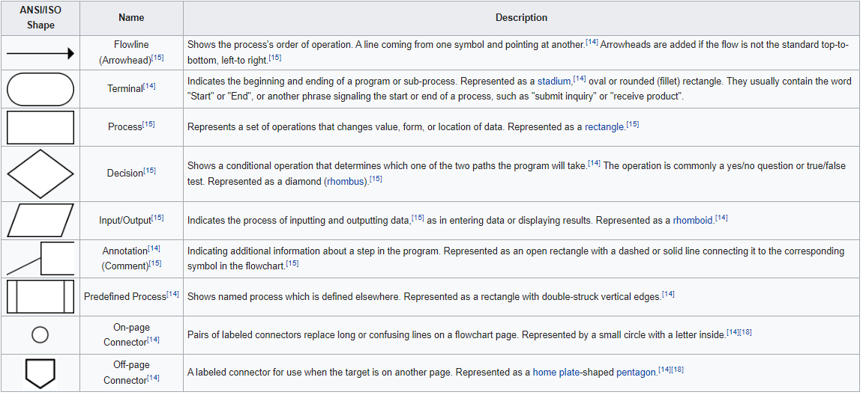

# Lab Tasks

**Lab Task 1**

Write java code and design flow chart that inputs three different integers from the user and then prints the average of three numbers.

**Lab Task 2**

A student needs to make the transcript and he is facing an issue in calculating his exact GPA of his semester #1 and semester #2.

His marks are stated below :

|  |  |  |  |  |
| --- | --- | --- | --- | --- |
| **Sr #** | **Course Name** | **Hr** | **Grade** | **Points** |
| **Semester # 1** | | | | |
| 1 | Into to Computer | 4.00 | A | 4.00 |
| 2 | Programming Fundamental | 4.00 | A- | 3.66 |
| 3 | Object Oriented Programming | 4.00 | B+ | 3.33 |
|  |  |  | GPA |  |
|  |  |  | CGPA |  |
| **Semester # 2** | | | | |
| 4 | Databases | 4.00 | A- | 3.66 |
| 5 | Computer Networks | 3.00 | B- | 2.66 |
| 6 | Web Application | 3.00 | B | 3.00 |
| 7 | Operating System | 4.00 | C | 2.00 |
|  |  |  | GPA |  |
|  |  |  | CGPA |  |

Your tasks are stated below to solve the above problem.

**Input:**

Extract the input from the above chart.

**Process:**

Devise a formula for calculating the GPA and CGPA.

**Output:**

Based on the process tell us the output.

**Make the sequential flowchart of above processes no conditions should be applied.**

**Lab Task 3**

Write java code and design flow chart that asks the user to enter two numbers, prints their sum, product, difference, quotient and remainder. (Arithmetic)

**Lab Task 4**

Calculate area of a rectangle as per the formula shown (area = base * height). The base and height will be input by the user.

**Lab Task 5**

Find the value of A such that the value of x, y and z will be input by the user.

|  |
| --- |
| **A = (4x – 3y) / 2z.** |

.

**Lab Task 6**

Write a java code and draw a flow chart that takes input distance between two cities (in km). Convert and print this distance in meters and centimeters.

1 km= 1000 m

1 m = 100 cm

**Lab Task 7**

A cashier has currency notes of denominations 10, 50 and 100. If the amount to be withdrawn is input through the keyboard in hundreds.

Write a java code and draw a flow chart that finds the total number of currency notes of each denomination the cashier will have to give to the withdrawer.

**Lab Task** 8

One metric ton is approximately 2205 pounds. Write a java code and draw a flowchart that prompts the user to input the amount of rice, in pounds, in a bag. The program outputs the number of bags needed to store one metric ton of rice.

**Lab Task** 9

Three cousins Jason, Dany and Jack. Dany is 4 years older than Jason. And Jack is half of the age of Dany. Write a java code and draw flow chart that takes Jason’s age as an input and than calculate the Age of Dany and Jack.